SET 4
Q1. Design an E-commerce Product Inventory schema using AI-assisted SQL generation.
- Include tables: Products, Suppliers, and Stock.
- Write SQL query to insert random data in each table
- Write an SQL query to find products with stock quantity less than 10.
Code:
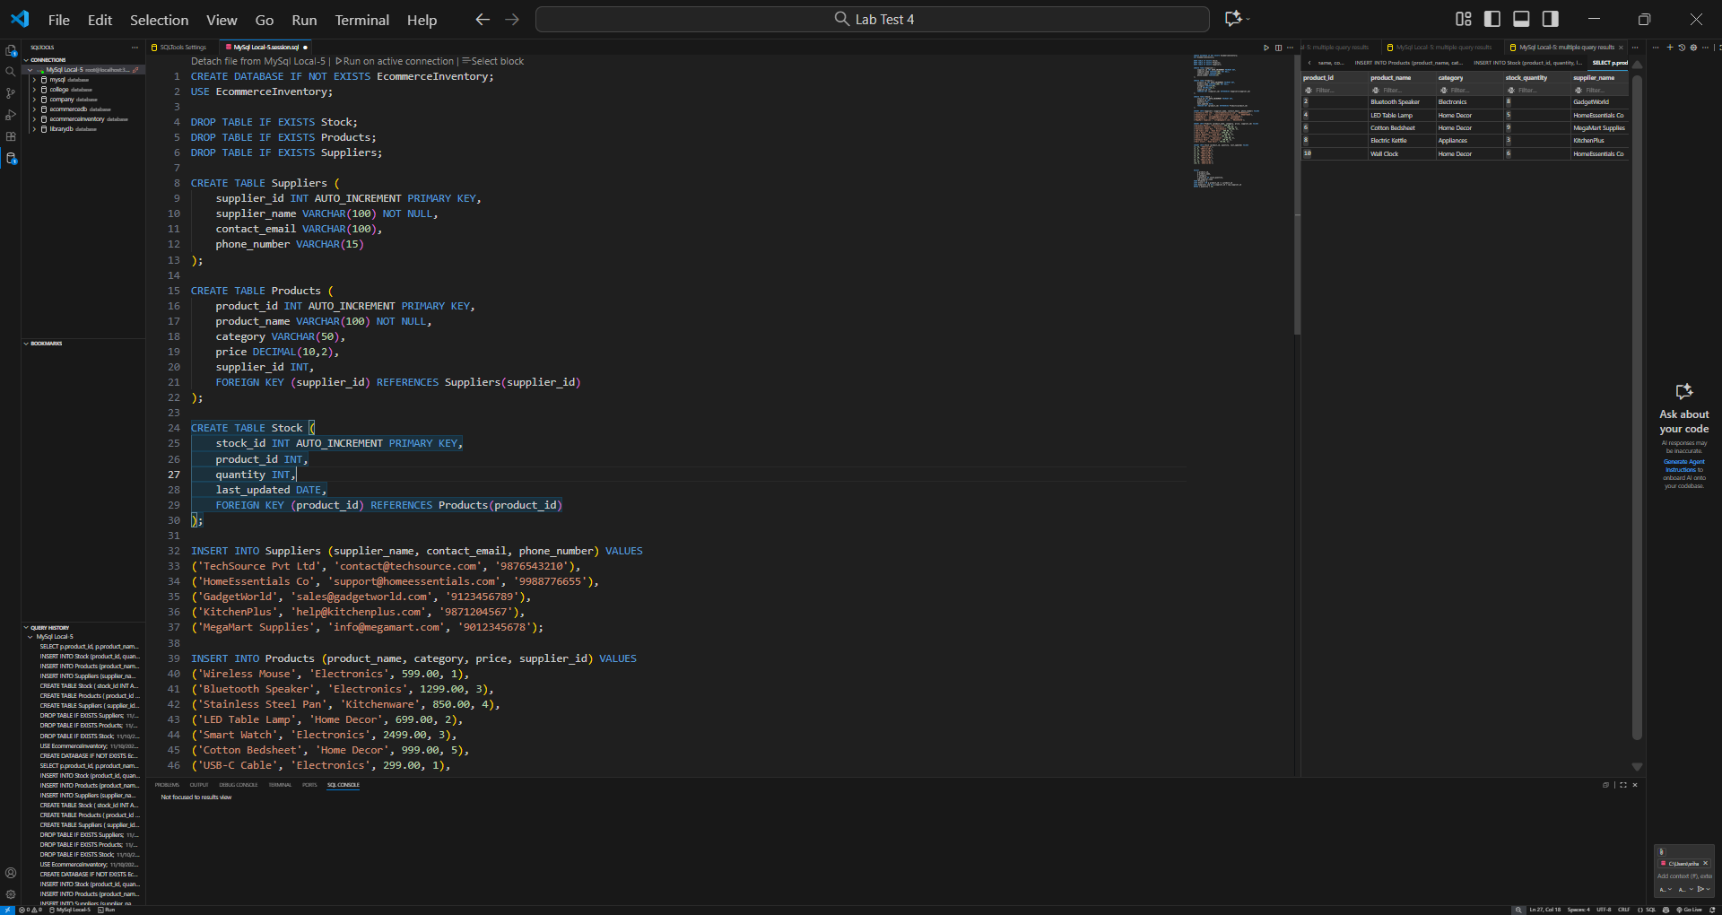
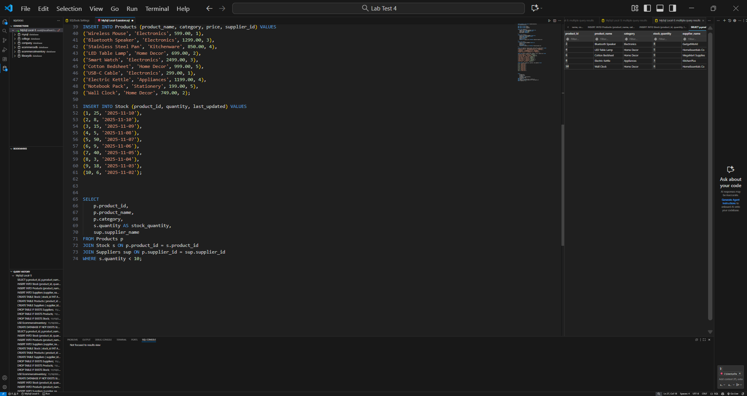
Ou put:
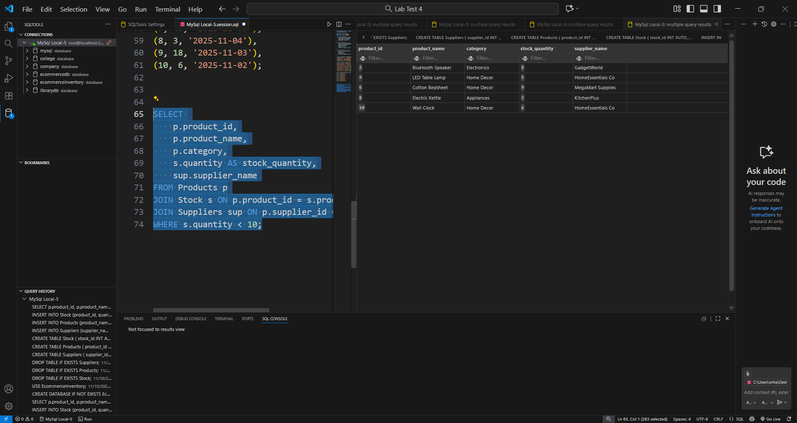

Q2. Generate an AI-assisted data cleaning script to:
- Generate dataset using ChatGPT that helps to complete the below two tasks
- Remove duplicates, handle NaN values, and standardize column names.
- Demonstrate the result using a sample CSV file


